Pareto Efficiency
-There are so many pairs of which PE=0 when CARA assumed
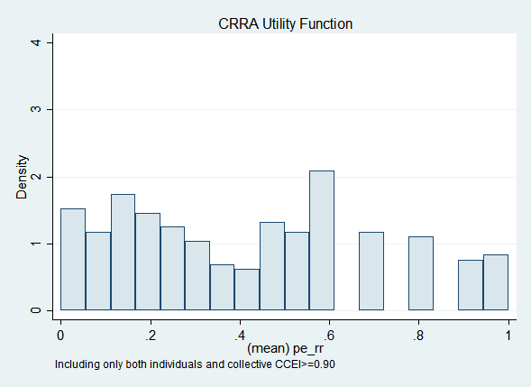 | 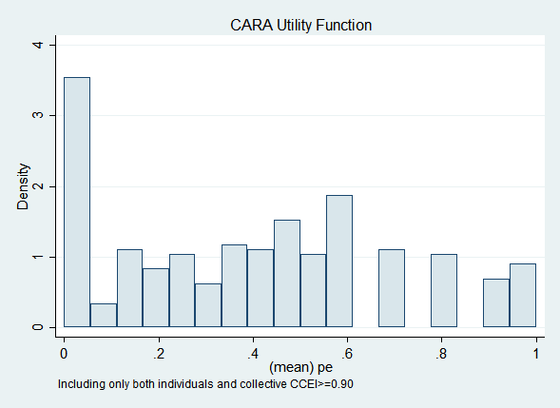

-However, estimation is more accurate when CARA assumed
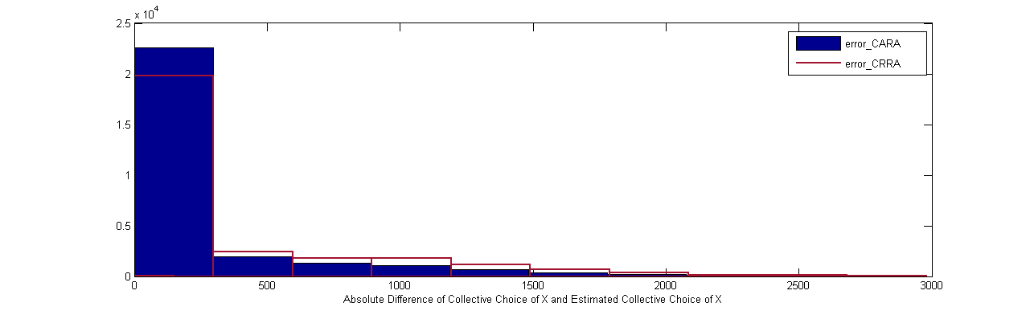

-Pairs with PE=0 but seems reasonable on the pairwise graph generally have patterns below
1) Two individuals’ risk preferences are so close to each other that minimal trembling yields non-Pareto efficiency.
2) More than one individual is extremely risk averse, which also lower Pareto efficiency with little trembling.

Possible solutions
- Permit trembling to some degree
- Use continuous utility loss measure
- Extend Pareto efficiency in a non-parametric way
- Change code for estimation of demand to be consistent to estimation of parameter. I mean, as we force alpha to be 0.5 when all choices are around 0.5, do a similar treatment to estimation of demand.

